**Assignment No:-31**

Name:-Suryawanshi Sangramsingh Sambhaji

Batch: - Delta - DCA (Java) 2024 Date:-19/6/2024

**1. Write a Java program that reads a string and counts the number of digits in the string.**

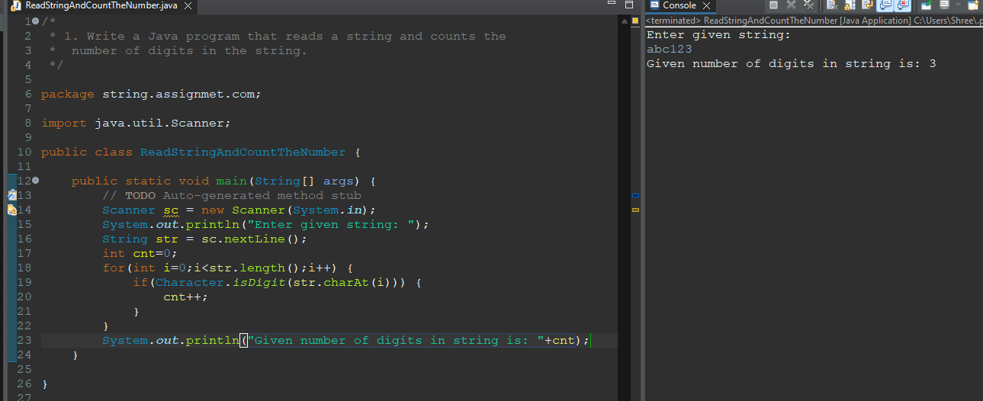

**2. Write a program that takes in a string and counts the number of vowels in it.**

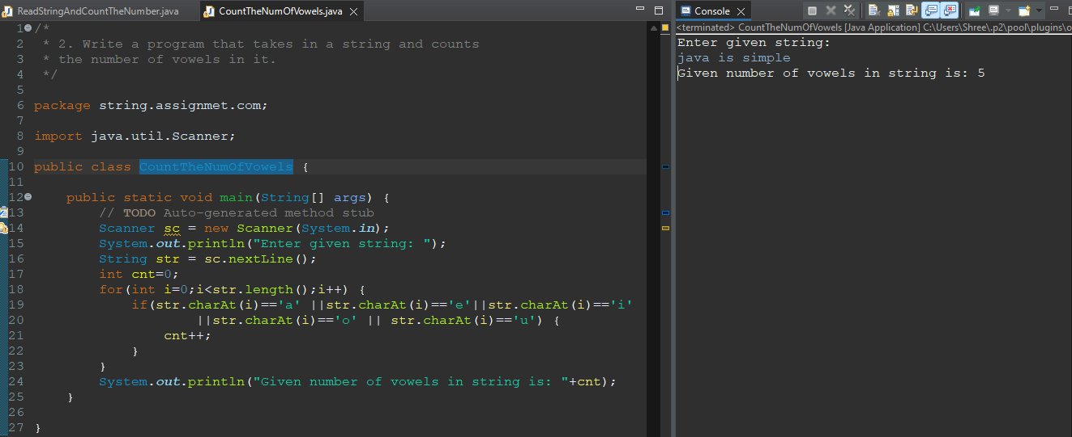

**3. Wap enter a string and the character present at even and odd position individually.**

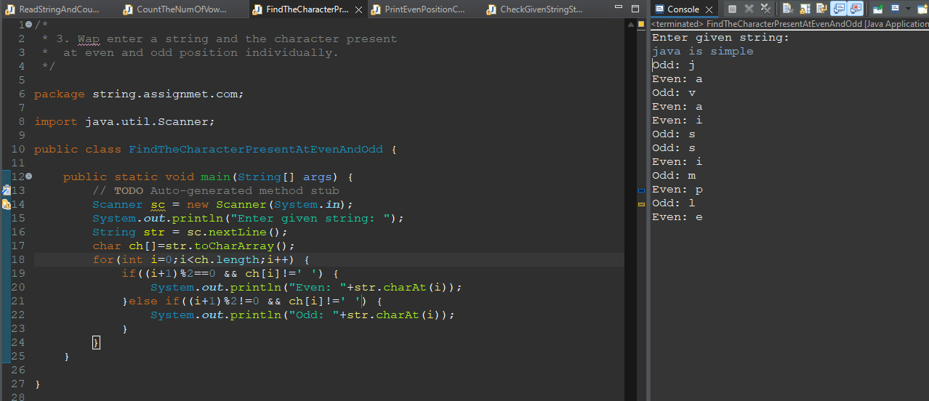

**4. Wap enter a string and print the character present at even position.**

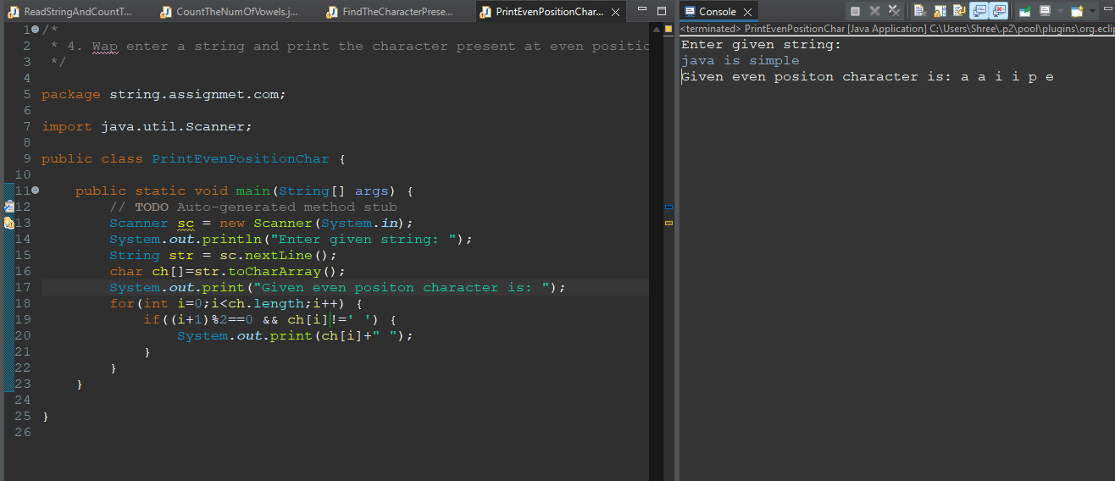

**5. Write a program to check if a given string starts with a vowel using charAt().**

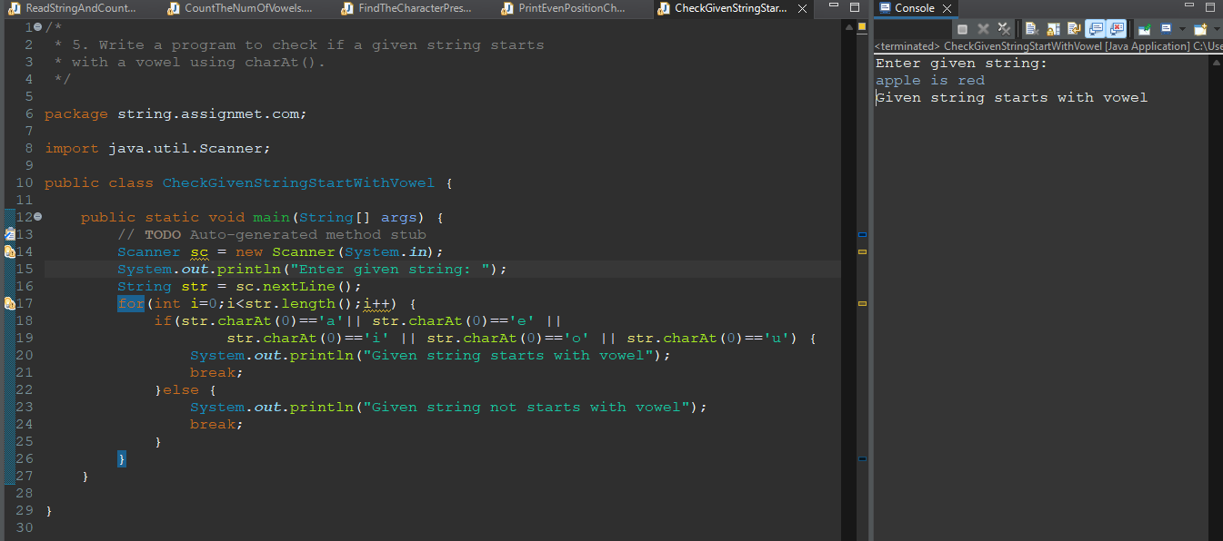

**6. Program to check if a string contains any special character**

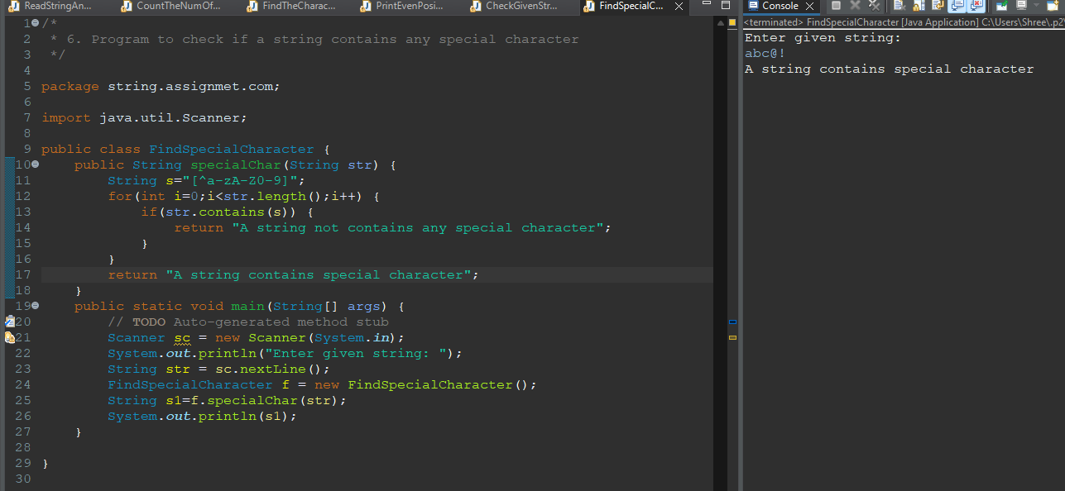

**7. WAP to replace all the odd index character with *(Star) in String.**

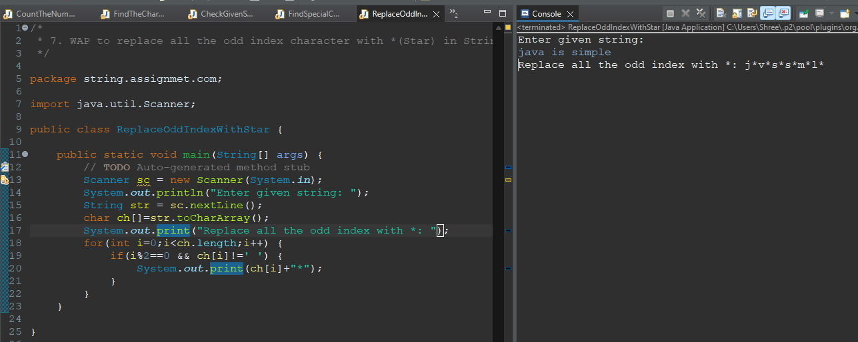

**8. WAP to replace all the even index charcter with #(hash) in String.**

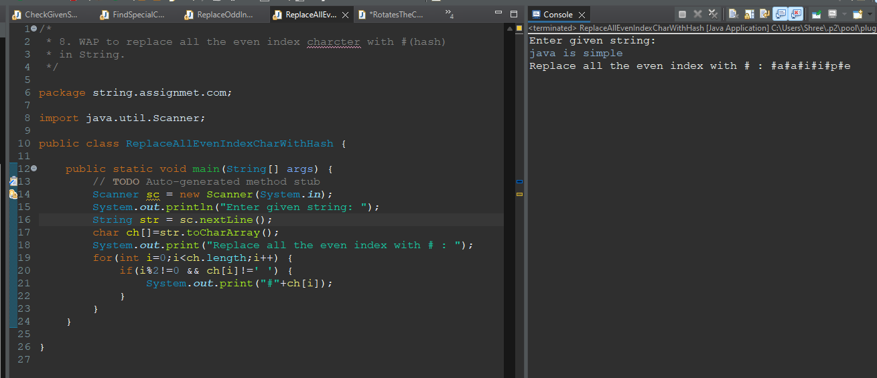

**9. Wap enter a string and rotate the character clockwise direction.**

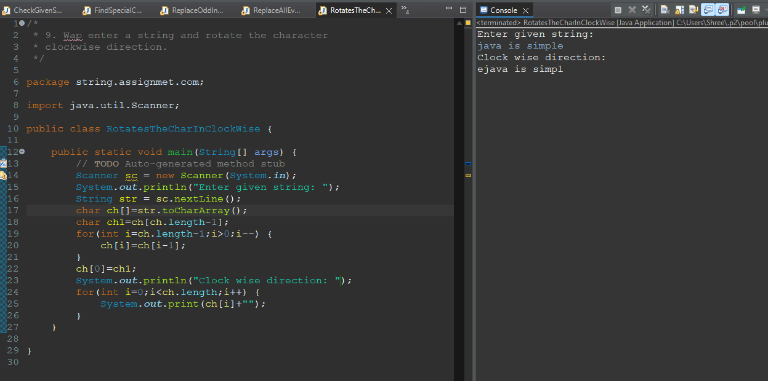

**10. Wap enter a string and rotate the character Anti-clockwise direction.**

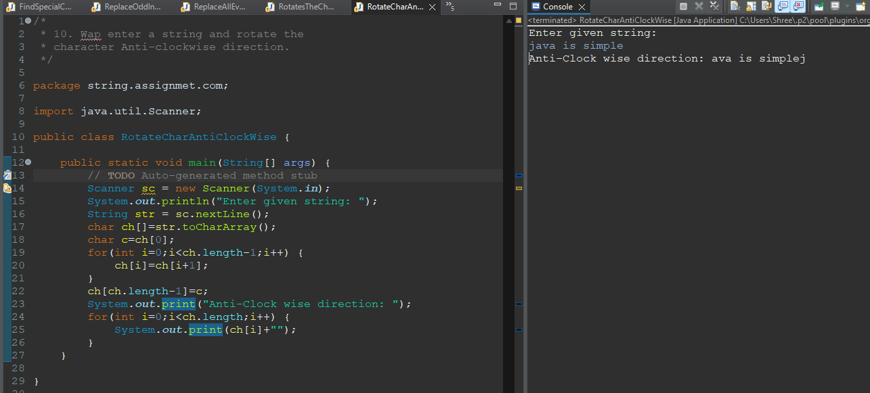

**11. Input : Geeks$For$Geeks Output : String is not accepted.**

**Input : Geeks For Geeks**

**Output : String is accepted**

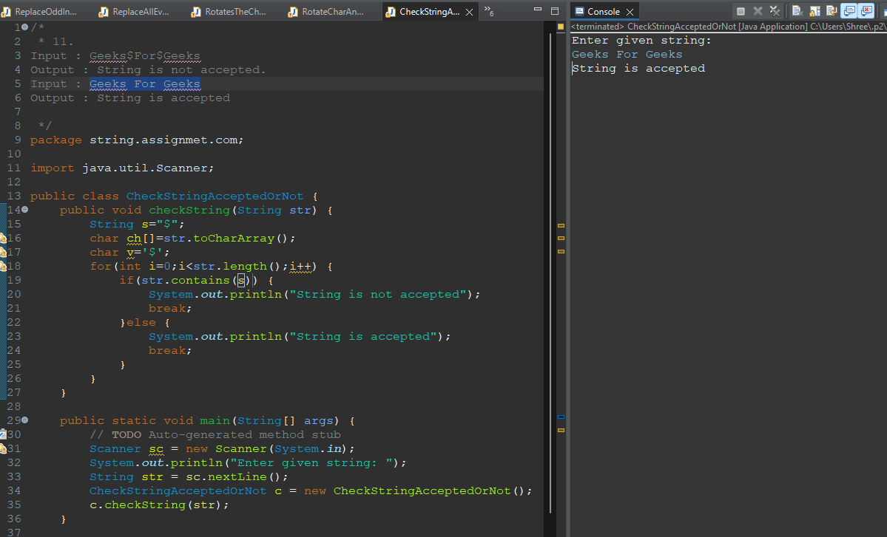

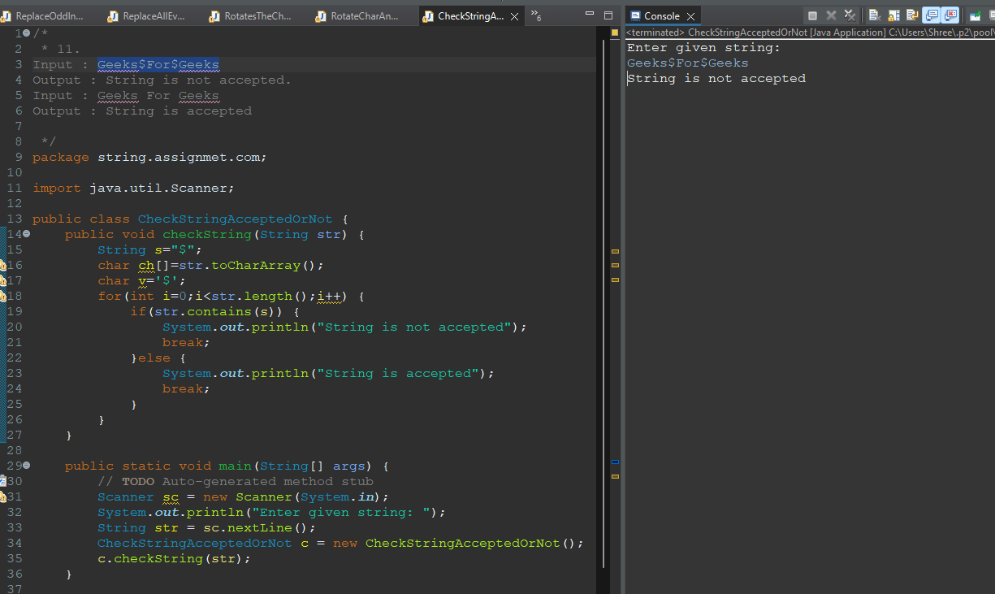

**Q12.Wap enter a string and find the count of uppercase, lowercase, digits and special**

**characters in a string.**

**The program should output the total count of digits found in the input string.**

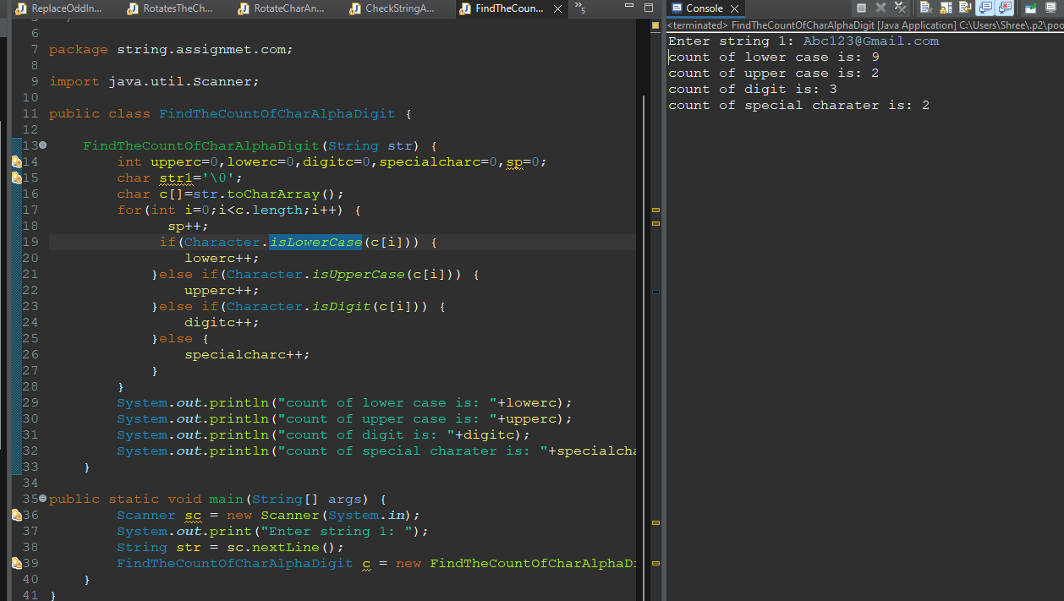

**Q13. Wap take a string and replace all whilespace with start(*).**

**i/p**

**String s=java is a very good programming language";**

**o/p**

**String s=java*is*a*very*good*programming*language;**

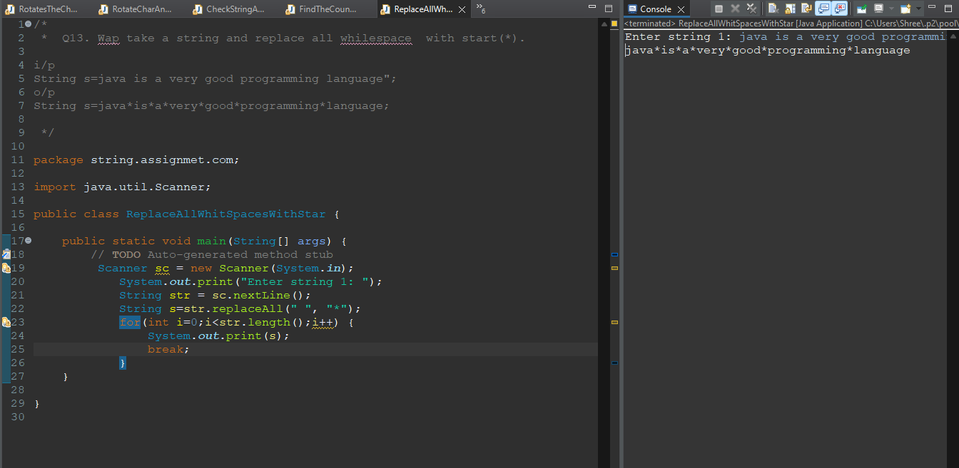

**Q14. Write a Java program to compare two strings**

**lexicographically, ignoring case differences.**

**Sample Output:**

**String 1: This is exercise 1**

**String 2: This is Exercise 1**

**"This is exercise 1" is equal to "This is Exercise 1"**

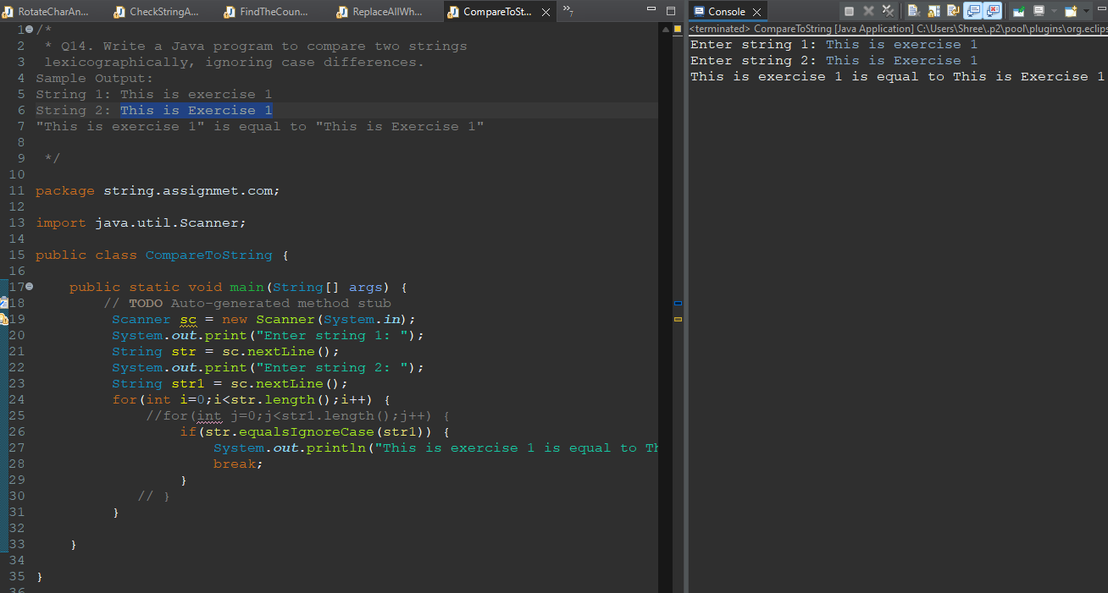

**Q15. WAP to reverse the word that are present at even index.**

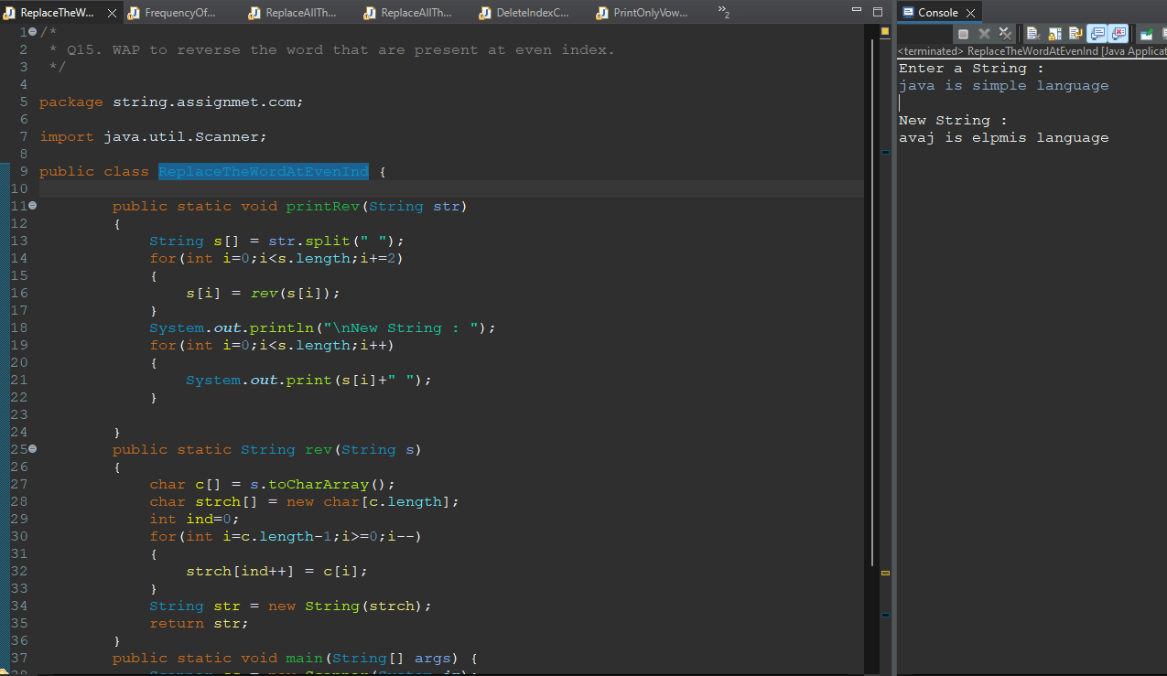 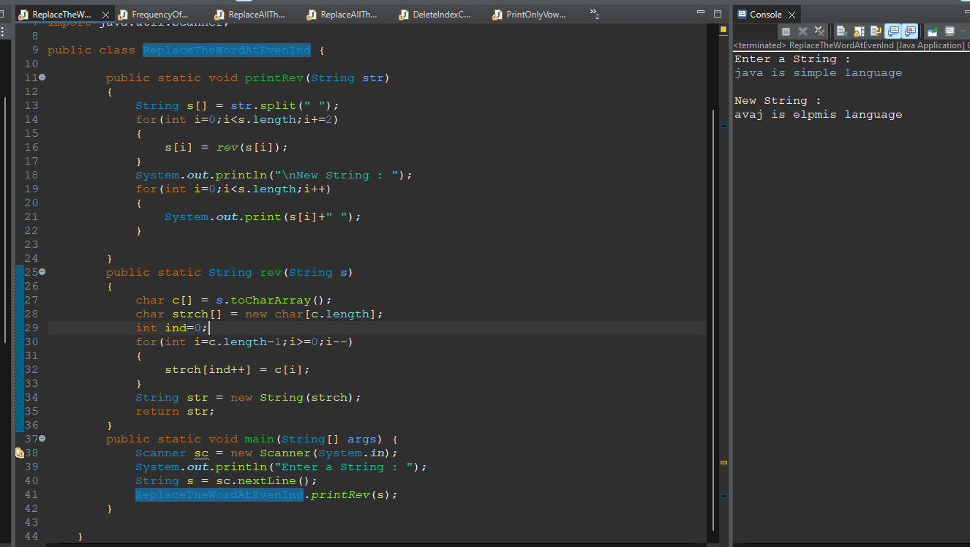

**Q16.write a program to rotate the word in string.**

**i/p : String s="my name is Atul";**

**o/p : String s= Atul is name my";"**

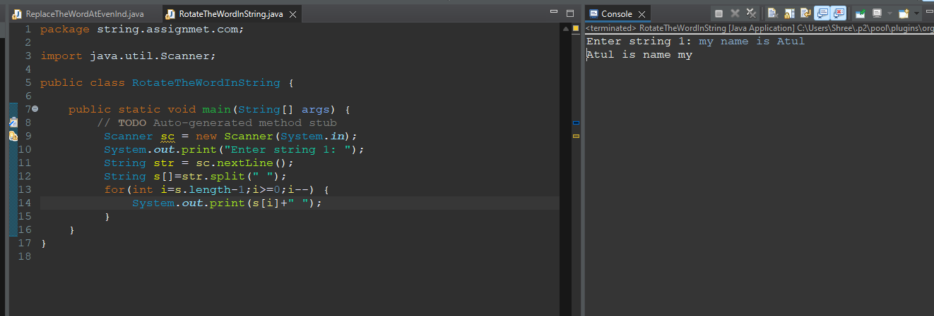

**Q17. WAP to print the frequncy of each word of String.**

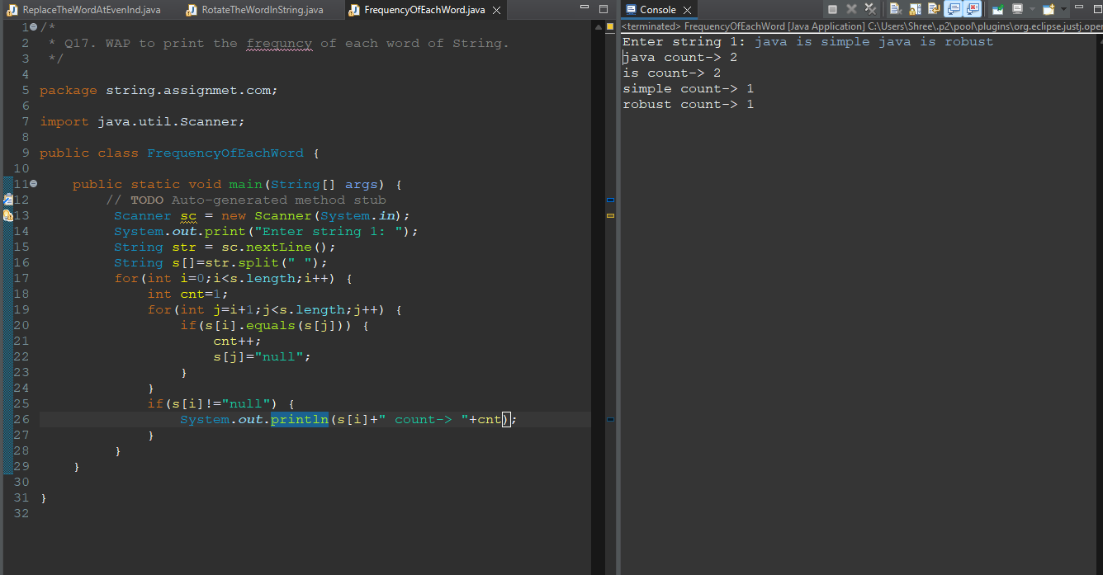

**Q18. WAP print all the words of String that are starting from vowel character.**

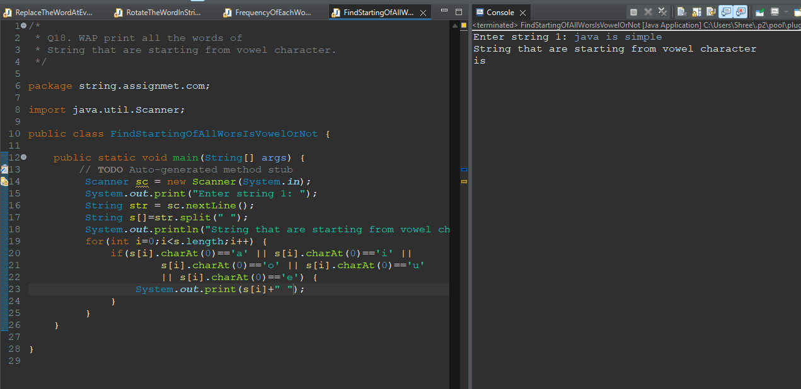

**Q19. WAP to replace all the words by INDIA that are prensent at even index.**

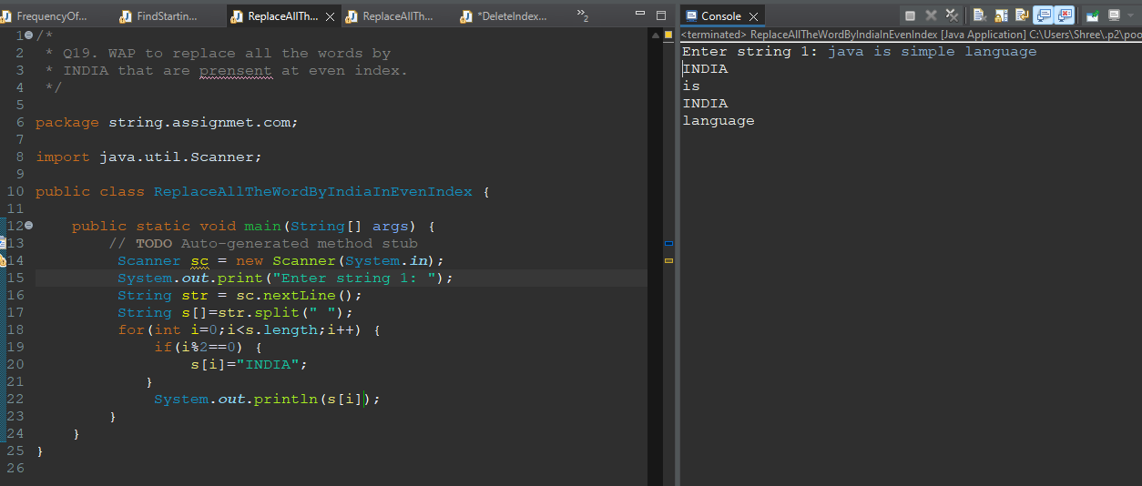

**Q20. WAP to replace all the words by welcome that are presenta at odd position.**

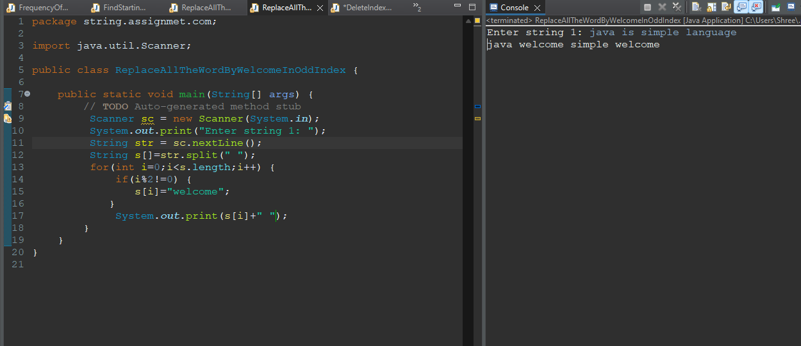

**Q21. String s="Welcome to the India"**

**Output: Wlcme t th nd**

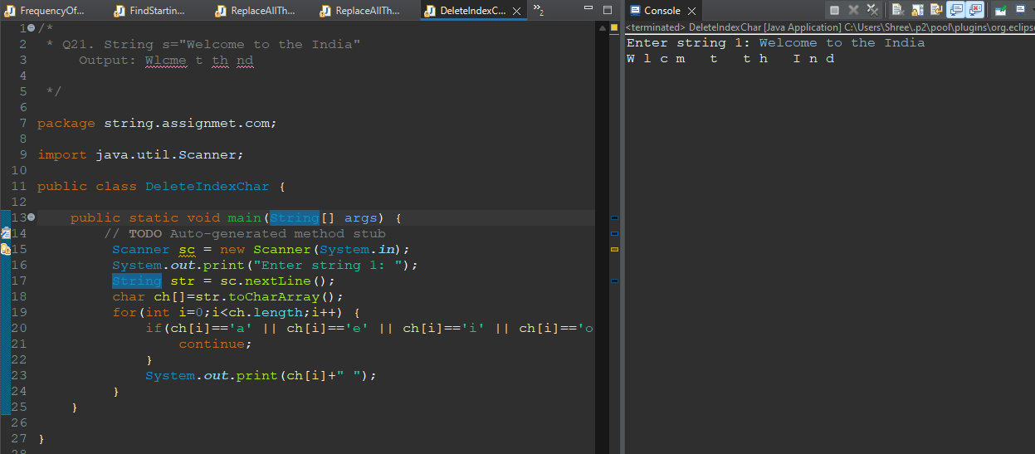

**Q22. String s1="Hello India"**

**Output: EO IIA**

